**Project Initialization and Planning Phase**

| Date | 12TH JULY 2024 |
| --- | --- |
| Team ID | SWTID1719935963 |
| Project Name | Automated Weather Classification using Transfer Learning |
| Maximum Marks | 3 Marks |

**Problem Statements :**

**Improving Accuracy of Weather Condition Identification:** Develop a transfer learning model to enhance the accuracy of classifying various weather conditions from satellite or ground-based images.

**Handling Diverse Weather Patterns**: Design a transfer learning system to accurately classify diverse and rare weather patterns, ensuring robustness across various geographic locations and seasons.

**Example:**

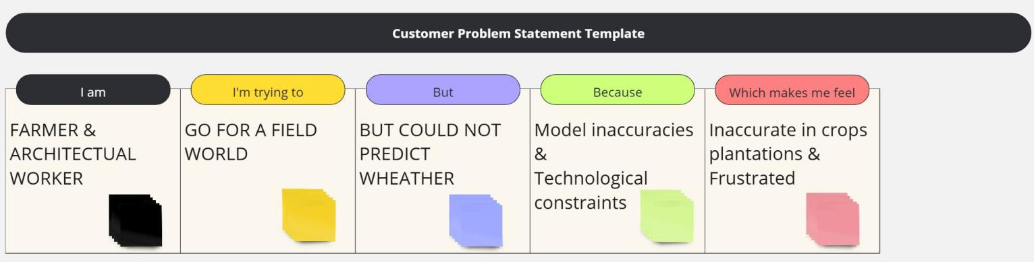

|  |  |  |  |  |  |
| --- | --- | --- | --- | --- | --- |
| **Problem**  **Statement (PS)** | **I am**  **(Customer)** | **I’m trying to** | **But** | **Because** | **Which makes me feel** |
| PS-1 | FARMER | GO FOR A FIELD WORLD | BUT COULD NOT PREDICT WHEATHER | Model inaccuracies &  Technological constraints | Inaccurate in crops plantations & Frustrated |
| PS-2 | CONSTRUCTIOAL WORKER | GO FOR A FIELD WORLD | BUT COULD NOT PREDICT WHEATHER | Technological constraints | Frustrated |